Data replication walkthrough

Author: André Freire (CIES-ISCTE-IUL)

This document summarizes a data replication walkthrough for anyone interested in replicating the results contained within the article “The Left-wing Governmental Alliance in Portugal, 2015-2019: A way for the renovation and rejuvenation of social democracy?”. The data sources and respective procedures are presented and described per each figure and table.

Figure 1: National Parliamentary Performance of Parties of the Left: Legislative Elections, 1975-2015

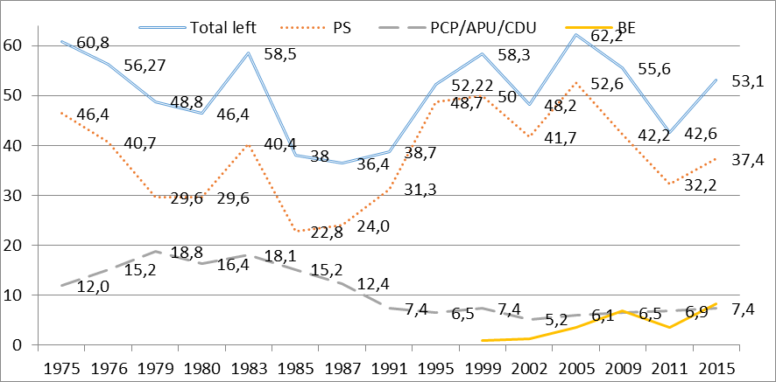
Sources: data elaborated by the author and taken from March and Freire (2012, p. 204) – 1975-2015-, always bearing on the official results published by CNE (National Electoral Commission): see www.cne.pt

Data sources:
COMISSÃO NACIONAL DE ELEIÇÕES (2017), Resultados Eleitorais. Available at < http://eleicoes.cne.pt/#assemb >. Accessed on July, 14, 2020.
SGMAI (2015), Eleições Legislativas 2015. Available at < https://www.eleicoes.mai.gov.pt/legislativas2015/resultados-globais.html >. Accessed on July, 14, 2020.

Procedure:
Every election data was taken from the websites, previously cited, and put on an Excel sheet, and then a Graph was ordered. The percentages were calculated discounting blank and null votes).
The data gathered from the various parties’ electoral results (PS, PCP/APU/CDU and BE) was then subjected to a sum, resulting in the “Total Left” line, per year, which can be observed in Figure 1.
Figure 2: Left-Right Position of Portuguese Political Parties (from 1–left to 10–right) according to voter perceptions of the ideological locations of parties (based on representative mass surveys), 1978-2015
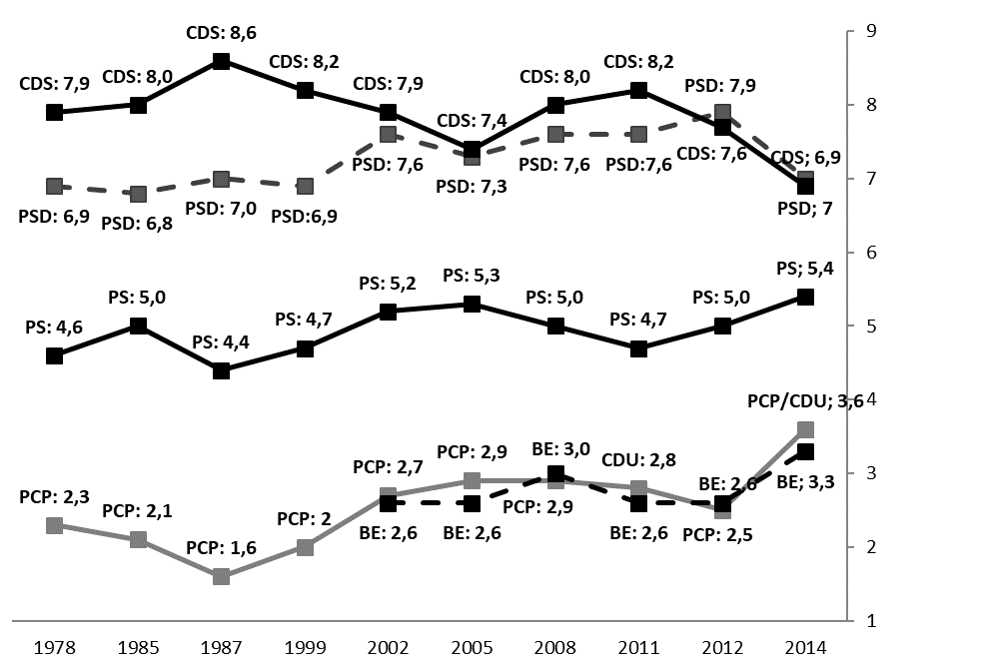
Sources: 1978–2014 data elaborated by the author from different sources: 1978, from Bacalhau (1994, p.134); 1985, from Mavrogordatos et al (1985); 1987 from Bacalhau (1987, p.102-121); 1999, from European Election Study (EES) 2009; 2002, from Barreto et al (2003); 2005, from Lobo et al (2019); 2008, from Freire, Viegas and Seiceira (2009); 2011, from Lobo and Magalhães (2019); 2012, from Freire, Viegas and Lisi (2012); 2014, from Belchior, Serra da Silva and Queiroga (2014).

Data Sources:
1978
Bacalhau, Mário (1994), Atitudes, Opiniões e Comportamentos Políticos dos Portugueses: 1973-1993, Lisboa. p.134.

1985
Mavrogordatos, George. Th.; Nicolacopolous, Ilias; Tsoucalas, Constantine; Guidorossi, Giovanna; Urbani, Giuliani; Mannheimer, Renato; Weber, Maria; Morlino, Leonardo; Bacalhau, Mário; Stock, Maria José; Conde, Rosa; Martinez, Usbaldo; Montero, José Ramón; Sani, Giacomo; Santamaria, Julian (1991), The Political Culture of Southern Europe: A Four Nation Study. GESIS Data Archive, Cologne. ZA2008 Data file Version 1.0.0. Available at < https://doi.org/10.4232/1.2008 > Accessed on July, 14, 2020.

1987
Bacalhau, Mário (1987), Sondagem de Opinião Política, Lisboa, ESEO, (policopiado).

1999
Eijk, Cees van der; Franklin, Mark; Schoenbach, Klaus; Schmitt, Hermann; Semetko, Holli; Brug, Wouter van der; Holmberg, Soeren; Mannheimer, Renato; Marsh, Michael; Thomassen, Jacques; and Wessels, Bernhard; (1999), European Election Study – 1999. International Research Group “European Election Studies”, IPSOS, Hamburg, Germany. Available at < http://dx.doi.org/10.17026/dans-z9j-vy6m > Accessed on July, 14, 2020.

2002
Barreto, António; Freire, André; Lobo, Marina Costa; and Magalhães, Pedro, (2003), As eleições legislativas de 2002 - Inquérito pós-eleitoral, 2002. Arquivo Português de Informação Social, Lisboa. APIS0005. Available at < http://hdl.handle.net/10400.20/27 > Accessed on July, 14, 2020.

2005
Lobo, Marina Costa; Magalhães, Pedro; Barreto, António; and Freire, André, (2019), Estudo Eleitoral Português 2005. Arquivo Português de Informação Social, Lisboa. APIS0042. Available at < http://hdl.handle.net/10400.20/2058 > Accessed on July, 14, 2020.

2008
Freire, André; Viegas, José Manuel; and Seiceira, Filipa, (2009), Representação Política em Portugal – Inquéritos e Bases de Dados, Lisboa, Sextante.

2011
Lobo, Marina Costa; and Magalhães, Pedro; (2019), Estudo Eleitoral Português 2011. Arquivo Português de Informação Social, Lisboa. APIS0043. Available at < http://hdl.handle.net/10400.20/2059 > Accessed on July, 14, 2020.

2012
Freire, André; Viegas, José M. L.; and Lisi, Marco (2012), «Inquérito aos Cidadãos Portugueses 2012», Projeto de Investigação do ISCTE-IUL e do CIES-IUL, «Eleições, Liderança e Responsabilização: A Representação Política em Portugal numa perspetiva longitudinal e comparativa», FCT: PTDC/CPJ-
CPO/119307/2010. Available at < http://er.cies.iscte-iul.pt/ > Accessed on July, 14, 2020.

2014
BELCHIOR, Ana Maria; SERRA DA SILVA, Sofia; and QUEIROGA, Viriato (2014), Panel Survey to the Portuguese population – First Wave, Project “Public Preferences and Policy Decision-Making. A Longitudinal and Comparative Analysis”, PTDC/IVC-CPO/3921/2012, CIES-IUL and ISCTE -IUL – Instituto Universitário de Lisboa.

Procedures:
Step 1: data collection
The data used in Figure 2 was gathered from 10 different sources (stated above). All collected data pertained to the Left-Right questions contained within the surveys. For this analysis’ objectives to be accomplished, it was needed to collect the Left-Right variable average, per party, and for each year. The data used for the years of 1978 and 1987 were not available in any Database format. However, the per-party averages, concerning the Left-Right variable, produced by those surveys was still available at the original author’s publication. Those same data can be checked at BACALHAU, 1994 (p.134) and at BACALHAU, 1987 (p.102-121), and was provided by this article’s author.

Step 2: variable harmonization
In order to assure comparability, all variable scales had to range within the same boundaries. As some of the surveys (1978, 1985, 1987 and 1999) ranged from 1 to 10, while the other years (2002, 2005, 2008, 2011, 2012 and 2014) ranged from 0 to 10, a formula was used to convert a 0-10 scale into 1-10 (Freire, 2006: 183, footnote 29).
The following table summarizes both the variables and the formulas used to obtain the parties’ averages.

Year | Variables name (and parties) | Original Scale | Formula used | New scale | New variable name
1978¹ | - | 1-10 | - | - | -
1985 | v105_pt (CDS/PP)  v107_pt (PCP)  v108_pt (PS)  v108_pt (PSD) | 1-10 | - | - | -
1987¹ | - | 1-10 | - | - | -
1999 | var118 (PS)  var119 (PSD)  var120 (CDS/PP)  var121 (CDU)  var122 (BE) | 1-10 | - | - | -
2002 | p.18_2 (BE)  p.18_3 (CDS/PP)  p.18_4 (CDU)  p.18_6 (PSD)  p.18_7 (PS) | 0-10 | V_ED*0,9+1=V_ED.r | 1-10 | p.18_2_rec (BE)  p.18_3_rec (CDS)  p.18_4_rec (CDU)  p.18_6_rec (PSD)  p.18_7_rec (PS)
2005 | p59.1 (BE)  p59.2 (CDS)  p59.3 (CDU)  p59.4 (PSD)  p59.5 (PS) | 0-10 | V_ED*0,9+1=V_ED.r | 1-10 | p59.1_rec (BE)  p59.2_rec (CDS)  p59.3_rec (CDU)  p59.4_rec (PSD)  p59.5_rec (PS)
2008 | GCS_E15_1 (BE)  GCS_E15_2 (CDS-PP)  GCS_E15_4 (PCP)  GCS_E15_5 (PSD)  GCS_E15_6 (PS) | 0-10 | V_ED*0,9+1=V_ED.r | 1-10 | GCS_E15_1_rec (BE)  GCS_E15_2_rec (CDS)  GCS_E15_4_rec (PCP)  GCS_E15_5_rec (PSD)  GCS_E15_6_rec (PS)
2011 | P54_1 (BE)  P54_2 (CDS)  P54_3 (CDU)  P54_4 (PSD)  P54_5 (PS) | 0-10 | V_ED*0,9+1=V_ED.r | 1-10 | P54_1_rec (BE)  P54_2_rec (CDS)  P54_3_rec (CDU)  P54_4_rec (PSD)  P54_5_rec (PS)
2012 | C.9.1 (BE)  C.9.2 (CDS)  C.9.4 (PCP)  C.9.5 (PSD)  C.9.6 (PS) | 0-10 | V_ED*0,9+1=V_ED.r | 1-10 | C.9.1_rec (BE)  C.9.2_rec (CDS)  C.9.4_rec (PCP)  C.9.5_rec (PSD)  C.9.6_rec (PS)
2014 | V15.1_D08_12 (BE)  V15.2_D08_12 (CDS)  V15.3_D08_12 (CDU)  V15.4_D08_12 (PSD)  V15.5_D08_12 (PS) | 0-10 | V_ED*0,9+1=V_ED.r | 1-10 | V15.1_D08_12_rec (BE)  V15.2_D08_12_rec (CDS)  V15.3_D08_12_rec (CDU)  V15.4_D08_12_rec (PSD)  V15.5_D08_12_rec (PS)
Note 1: the data used for the years of 1978 and 1987 were not available in any Database format. However, the per-party averages, concerning the Left-Right variable, produced by those surveys was still available at the original author’s publication. Those same data can be checked at Bacalhau, 1994 (p.134) and at Bacalhau, 1987 (p.102-121), and was provided by this article’s author.

As such, through the application of the formula V_ED*0,9+1=V_ED.r (Freire, 2006: 183, footnote 29), all the previously indicated variables were subjected to the scale conversion (by using the command “COMPUTE” in SPSS, in which the original variable is “V_ED” and the recoded variable is “V_ED.r”).

Step 3: average calculous
The next step asks the statistics program (SPSS) to calculate the average of the Left vs Right Positioning for each party, in each survey (and, thus, year). As to the 1978 and 1987 survey data, the averages where already available, thus, this data was saved as was provided within the respective publications.

Step 4: graph construction
All saved data, separated into parties per year, within an Excel sheet (also provided) was commanded to produce a 2D Line Graph, which elicits the results stated in Figure 2.
Table 1: Portuguese attitudes towards left-wing governments (2014) – by party sympathy (% of each group total)
Q: Imagine that the general election has been held and that the PS won, but without an absolute majority. Which one of the following options do you think would be better for the country (choose only one)? It would be better for the country for the PS to…
 | CDU/PCP | BE | PS | PSD | CDS-PP
Rule in minority | 11.1 | 12.8 | 21.1 | 19.3 | 11.9
Form a coalition with the radical left | 69.1 | 66.7 | 41.8 | 7.5 | 7.2
Form a coalition with the right | 2.5 | 5.2 | 21.6 | 54.1 | 57.2
Form a coalition with all parties | 17.3 | 15.4 | 15.4 | 19.3 | 23.8
N | 81 | 39 | 227 | 161 | 42
Source: Data elaborated by the author based on a representative sample of the adult Portuguese population living in the mainland, N = 1205, fielded between June and October 2014. See Belchior, Silva and Queiroga (2014).

Data source:
BELCHIOR, Ana Maria; SERRA DA SILVA, Sofia; and QUEIROGA, Viriato (2014), Panel Survey to the Portuguese population – First Wave, Project “Public Preferences and Policy Decision-Making. A Longitudinal and Comparative Analysis”, PTDC/IVC-CPO/3921/2012, CIES-IUL and ISCTE -IUL – Instituto Universitário de Lisboa.

Procedures:
Step 1: data collection
All data used belongs to the previously mentioned source.

Step 2: Variables used
After gathering the data, two variables were used (V16_D08_12 and V42.2), and the response categories necessary were selected. All these procedures are shown in the table, below.

Variable name | Question formulation | Response categories | Selected categories | Categories in English
V16_D08_12 | Existe algum partido político do qual se sinta mais próximo? SE SIM: Qual é esse partido? | 1 – BE  2 – CDS  3 – CDU  4 – PS  5 – PSD  6 – Outro  7 – Não me considero próximo/a de nenhum partido político  98 - Não sabe  99 - Recusa responder | 1 – BE  2 – CDS  3 – CDU  4 – PS  5 – PSD | 1 – BE  2 – CDS  3 – CDU  4 – PS  5 – PSD
V42.2 | Imagine que amanhã se realizavam eleições legislativas e que o PS ganhava as eleições, mas sem maioria absoluta. Qual das seguintes possibilidades seria melhor para o país (escolha apenas uma opção de resposta)? Seria melhor para o país que o PS… | 1 - Governasse em minoria  2 - Fizesse uma coligação com a CDU  3 - Fizesse uma coligação com o BE  4 - Fizesse uma coligação com a CDU e o BE  5 - Fizesse uma coligação com o CDS-PP  6 - Fizesse uma coligação com o PSD  7 - Fizesse uma coligação com o CDS-PP e o PSD  8 - Fizesse uma coligação com todos os partidos parlamentares  98 - Não sabe  99 - Recusa responder | 1 - Governasse em minoria  4 - Fizesse uma coligação com a CDU e o BE  7 - Fizesse uma coligação com o CDS-PP e o PSD  8 - Fizesse uma coligação com todos os partidos parlamentares | 1 - Rule in minority  4 - Form a coalition with the radical left  7 - Form a coalition with the right  8 - Form a coalition with all parties

Step 3: Analysis and data breakdown
In order to analyse the previously mentioned variables, the command “Split file” was used, in order to divide the Database into the interviewees who had sympathy towards the five considered Portuguese political parties. Then, after commanding the software to analyse the frequencies, the data, corresponding to each selected category of the V42.2 variable was taken and saved as the Table 1.

Table 2: Elections to the Portuguese Parliament (2015, 2011 and 2009)
 | 2015 |  |  | 2011 |  |  | 2009
 | Seats |  | Votes | Seats |  | Votes | Seats |  | Votes
Parties | N | % | % | N | % | % | N | % | %
PàF | 107 | 46.5 | 38.56 | - | - | 50.4 | - | - | 39.5
PSD | 89 | 39.0 | 32.0 | 108 | 46.9 | 38.7 | 81 | 35.2 | 29.1
PS | 86 | 37.4 | 32.3 | 74 | 32.2 | 28.1 | 97 | 42.2 | 36.6
BE | 19 | 8.3 | 10.2 | 8 | 3.5 | 5.2 | 16 | 6.9 | 9.8
CDS-PP | 18 | 7.8 | 6.56 | 24 | 10.4 | 11.7 | 21 | 9.1 | 10.4
PCP/PEV | 17 | 7.4 | 8.25 | 16 | 6.9 | 7.9 | 15 | 6.5 | 7.7
PAN | 1 | 0.43 | 1.39 | - | - | - | - | - | -
Others | 0 | 0.0 | 5.16 | 0 | 0.0 | 4.4 | 0 | 0.0 | 3.1
Invalid and blank votes |  |  | 4.14 | - | - | 4.0 | - | - | 3.1
Total | 230 | 100 | 100 | - | - | 100 | 230 | 100 | 100
Turnout |  |  | 56.1 |  |  | 58.0 | - | - | 60.5
Sources: www.cne.pt
Notes: In Portuguese elections invalid and blank votes are counted as a percentage of the total vote; Portugal Ahead (PàF – Portugal à Frente) was a pre-electoral coalition of the PSD and CDS-PP (except in Madeira, where they ran separately); the total vote for PàF (38.56%) were disaggregated using the proportion of the 107 seats in parliament each of the parties in the coalition has (PSD: 0.83; CDS-PP: 0.17) as a multiplier. PàF only ran together in 2015, but for the sake of comparing the electoral strength of the right across elections we also calculate it for 2011 and 2009.

Data sources:
COMISSÃO NACIONAL DE ELEIÇÕES (2017) Resultados Eleitorais. Available at < http://eleicoes.cne.pt/#assemb >. Accessed on July, 14, 2020.
SGMAI (2015), Eleições Legislativas 2015. Available at < https://www.eleicoes.mai.gov.pt/legislativas2015/resultados-globais.html >. Accessed on July, 14, 2020.

Procedure:
Every election data was taken from the websites, previously cited, and used as were provided by the original source.
Table 3: Left-Right (L-R) ideological distances between pairs of parties in Portugal, 1978-2015
 | Date of mass survey measuring L-R position
Distances between Parties | 1978 | 1987 | 2002 | 2012 | 2014 | 2015
PS – CDS | -3,3 | -4,2 | -2,7 | -2,7 | -1,5 | -3,7
PS – PSD | -2,3 | -2,6 | -2,4 | -2,9 | -1,6 | -3,7
PCP – PS | -2,5 | -2,8 | -2,5 | -2,5 | -1,8 | -2,3
BE – PS |  |  | -2,6 | -2,4 | -2,4 | -2,2
Sources: data calculated by the author based on the party averages presented in Figure 2 above.

Data Sources:
1978
BACALHAU, Mário (1994), Atitudes, Opiniões e Comportamentos Políticos dos Portugueses: 1973-1993, Lisboa. p.134.

1987
BACALHAU, Mário (1987), Sondagem de Opinião Política, Lisboa, ESEO, (policopiado).

2002
BARRETO, António; FREIRE, André; LOBO, Marina Costa; and MAGALHÃES, Pedro, (2003), As eleições legislativas de 2002 - Inquérito pós-eleitoral, 2002. Arquivo Português de Informação Social, Lisboa. APIS0005. Available at < http://hdl.handle.net/10400.20/27 > Accessed on July, 14, 2020.

2012
FREIRE, André; VIEGAS, José M. L.; and LISI, Marco (2012), «Inquérito aos Cidadãos Portugueses 2012», Projeto de Investigação do ISCTE-IUL e do CIES-IUL, «Eleições, Liderança e Responsabilização: A Representação Política em Portugal numa perspetiva longitudinal e comparativa», FCT: PTDC/CPJ-
CPO/119307/2010. Available at < http://er.cies.iscte-iul.pt/ > Accessed on July, 14, 2020.

2014
BELCHIOR, Ana Maria, SERRA DA SILVA, Sofia, and QUEIROGA, Viriato (2014), Panel Survey to the Portuguese population – First Wave, Project “Public Preferences and Policy Decision-Making. A Longitudinal and Comparative Analysis”, PTDC/IVC-CPO/3921/2012, CIES-IUL and ISCTE -IUL – Instituto Universitário de Lisboa.

2015
Lobo, Marina Costa; Magalhães, Pedro; and Gaspar, João Tiago (2019), Estudo Eleitoral Português 2015. Arquivo Português de Informação Social, Lisboa. APIS0040. Available at < http://hdl.handle.net/10400.20/2056 > Accessed on July, 14, 2020.

Procedures:

Step 1: data collection
The data used in Figure 2 was gathered from 6 different sources (stated above). All collected data pertained to the Left-Right questions contained within the surveys. For this analysis’ objectives to be accomplished, it was needed to collect the Left-Right variable average, per party, and for each year. The data used for the years of 1978 and 1987 were not available in any Database format. However, the per-party averages, concerning the Left-Right variable, produced by those surveys was still available at the original author’s publication. Those same data can be checked at BACALHAU, 1994 (p.134) and at BACALHAU, 1987 (p.102-121), and was provided by this article’s author.

Step 2: variable harmonization
In order to assure comparability, all variable scales had to range within the same boundaries. As some of the surveys (1978 and 1987) ranged from 1 to 10, while the other years (2002, 2005, 2008, 2011, 2012 and 2014) ranged from 0 to 10, a formula was used to convert a 0-10 scale into 1-10 (Freire, 2006: 183, footnote 29).
The following table summarizes both the variables and the formulas used to obtain the parties’ averages.

Year | Variables name (and parties) | Original Scale | Formula used | New scale | New variable name
1978¹ | - | 1-10 | - | - | -
1987¹ | - | 1-10 | - | - | -
2002 | p.18_2 (BE)  p.18_3 (CDS/PP)  p.18_4 (CDU)  p.18_6 (PSD)  p.18_7 (PS) | 0-10 | V_ED*0,9+1=V_ED.r | 1-10 | p.18_2_rec (BE)  p.18_3_rec (CDS)  p.18_4_rec (CDU)  p.18_6_rec (PSD)  p.18_7_rec (PS)
2012 | C.9.1 (BE)  C.9.2 (CDS)  C.9.4 (PCP)  C.9.5 (PSD)  C.9.6 (PS) | 0-10 | V_ED*0,9+1=V_ED.r | 1-10 | C.9.1_rec (BE)  C.9.2_rec (CDS)  C.9.4_rec (PCP)  C.9.5_rec (PSD)  C.9.6_rec (PS)
2014 | V15.1_D08_12 (BE)  V15.2_D08_12 (CDS)  V15.3_D08_12 (CDU)  V15.4_D08_12 (PSD)  V15.5_D08_12 (PS) | 0-10 | V_ED*0,9+1=V_ED.r | 1-10 | V15.1_D08_12_rec (BE)  V15.2_D08_12_rec (CDS)  V15.3_D08_12_rec (CDU)  V15.4_D08_12_rec (PSD)  V15.5_D08_12_rec (PS)
2015 | P50.1 (BE)  P50.2 (CDS)  P50.3 (CDU)  P50.4 (PSD)  P50.5 (PS) | 0-10 | V_ED*0,9+1=V_ED.r | 1-10 | P50.1_rec (BE)  P50.2_rec (CDS)  P50.3_rec (CDU)  P50.4_rec (PSD)  P50.5_rec (PS)
Note 1: the data used for the years of 1978 and 1987 were not available in any Database format. However, the per-party averages, concerning the Left-Right variable, produced by those surveys was still available at the original author’s publication. Those same data can be checked at Bacalhau, 1994 (p.134) and at Bacalhau, 1987 (p.102-121), and was provided by this article’s author.

As such, through the application of the formula V_ED*0,9+1=V_ED.r (Freire, 2006: 183, footnote 29), all the previously indicated variables were subjected to the scale conversion (by using the command “COMPUTE” in SPSS, in which the original variable is “V_ED” and the recoded variable is “V_ED.r”).

Step 3: average calculation
The next step asks the statistics program (SPSS) to calculate the average of the Left vs Right Positioning for each party, in each survey (and, thus, year). As to the 1978 and 1987 survey data, the averages where already available, thus, this data was saved as was provided within the respective publications.

Step 4: Distances between Parties
All the averages provided by the respective surveys was saved, separated into parties per year, within an Excel sheet (also provided). Then, all data was subjected to a calculous, in order to know the distance between the PS and each of the other parties, as indicated on Table 3.
TTable 4: Attitudes of Portuguese vis-à-vis the centre-left and radical left (support) Government, April-June 2016, by party sympathy (% of the total in each group)
As with the right-wing parties in Portugal, have the left-wing parties (PS, BE and PCP/PEV) done well by reaching an agreement to govern?
 | Voter party sympathy
 | BE | PCP-PEV | PS | PSD | CDS-PP | Without party sympathy | Total
Totally disagree | 0,5 | 0,6 | 0,5 | 39,6 | 29,6 | 6,5 | 9,9
Disagree | 9,1 | 4,7 | 4,2 | 19,6 | 22,2 | 13,9 | 12,4
Neither disagree, nor agree | 13,9 | 19,9 | 13,1 | 22,3 | 29,6 | 37,4 | 28,4
Agree | 35,8 | 39,8 | 49,9 | 15,8 | 17,3 | 31,3 | 32,6
Totally agree | 40,6 | 35,1 | 32,3 | 2,6 | 1,2 | 10,9 | 16,8
N (100%) | 187 | 171 | 450 | 341 | 81 | 1408 | 2650
Source: data calculated by the author from Freire, Lisi and Tsatsanis (2016). Weighted data by education.

Data Source:
Freire, André; Lisi, Marco; and Tsatsanis, Emmanouil (2016), Portuguese Citizens Survey 2016-2018, research project at CIES-IUL and IPRI-NOVA, “Crisis, Political Representation and Democratic Renewal: The Portuguese case in the Southern European context”, FCT: PTDC/IVC-CPO/3098/2014. Available at < http://er.cies.iscte-iul.pt/ > Accessed on July, 14, 2020.

Procedures:
Step 1: data collection
All data used belongs to the previously mentioned source.

Step 2: Variables used
After gathering the data, two variables were used (EES_C9 and CS_I28.4), and the response categories necessary were selected. All these procedures are shown in the table, below.

Variable name | Question formulation | Response categories | Selected categories | Categories in English
EES_C9 | Considera-se próximo/a de um partido político em particular? Se sim, importa-se de dizer qual é esse partido? | 1 – BE  2 – CDS  3 – CDU  4 – PS  5 – PSD  6 – Outro  7 – Não me considero próximo/a de nenhum partido político  98 - Não sabe  99 - Recusa responder | 1 – BE  2 – CDS  3 – CDU  4 – PS  5 – PSD  7 – Não me considero próximo/a de nenhum partido político | 1 – BE  2 – CDS  3 – CDU  4 – PS  5 – PSD  7 – Without party sympathy
CS_I28.4 | À semelhança do que acontece com os partidos de direita em Portugal, os partidos de esquerda (PS, BE e PCP/PEV) fizeram bem em entender-se para viabilizar o presente governo | 1 – Discorda totalmente  2 – Discorda  3 – Não concorda nem discorda  4 – Concorda  5 – Concorda totalmente | 1 – Discorda totalmente  2 – Discorda  3 – Não concorda nem discorda  4 – Concorda  5 – Concorda totalmente | 1 – Totally disagree  2 – Disagree  3 – Neither disagree, nor agree  4 – Agree  5 – Totally agree

Step 3: Analysis and data breakdown
In order to analyse the previously mentioned variables, it was commanded to the software (SPSS) a command CROSSTAB, in order to cross both these variables. The results of such operation are shown on table 4.

Table 5: Attitudes of the Portuguese vis-à-vis the centre-left and radical left (support) Government’s general performance, April-June 2016, by party sympathy (% of the total in each group).
Thinking about the OVERALL PERFORMANCE of the current Socialist government, which is supported in parliament by the BE and PCP-PEV, how would you rate this government’s efforts? Would you say it has done a very good job, a good job, a bad job or a very bad job?

 | Voters’ party sympathy
 | BE | PCP-PEV | PS | PSD | CDS-PP | Without party sympathy | Total
Very bad | 2,1 | 5,3 | 2,7 | 22,9 | 15,0 | 8,5 | 9,0
Bad | 14,4 | 10,5 | 5,4 | 41,6 | 55,0 | 38,8 | 30,8
Good | 71,8 | 78,4 | 79,8 | 34,6 | 30,0 | 50,9 | 56,0
Very good | 11,7 | 5,8 | 12,1 | 0,9 | 0,0 | 1,7 | 4,2
N (100%) | 188 | 171 | 406 | 341 | 80 | 1408 | 2651
Source: data computed by the author from Freire, Lisi and Tsatsanis (2016). Weighted data by education.

Data Source:
Freire, André; Lisi, Marco; and Tsatsanis, Emmanouil (2016), Portuguese Citizens Survey 2016-2018, research project at CIES-IUL and IPRI-NOVA, “Crisis, Political Representation and Democratic Renewal: The Portuguese case in the Southern European context”, FCT: PTDC/IVC-CPO/3098/2014. Available at < http://er.cies.iscte-iul.pt/ > Accessed on July, 14, 2020.

Procedures:
Step 1: data collection
All data used belongs to the previously mentioned source.

Step 2: Variables used
After gathering the data, two variables were used (EES_C9 and CEAPP05_D11), and the response categories necessary were selected. All these procedures are shown in the table, below.

Variable name | Question formulation | Response categories | Selected categories | Categories in English
EES_C9 | Considera-se próximo/a de um partido político em particular? Se sim, importa-se de dizer qual é esse partido? | 1 – BE  2 – CDS  3 – CDU  4 – PS  5 – PSD  6 – Outro  7 – Não me considero próximo/a de nenhum partido político  98 - Não sabe  99 - Recusa responder | 1 – BE  2 – CDS  3 – CDU  4 – PS  5 – PSD  7 – Não me considero próximo/a de nenhum partido político | 1 – BE  2 – CDS  3 – CDU  4 – PS  5 – PSD  7 – Without party sympathy
CEAPP05_D11 | À semelhança do que acontece com os partidos de direita em Portugal, os partidos de esquerda (PS, BE e PCP/PEV) fizeram bem em entender-se para viabilizar o presente governo | 1 – Muito mau  2 – Mau  3 – Bom  4 – Muito bom | 1 – Muito mau  2 – Mau  3 – Bom  4 – Muito bom | 1 – Very bad  2 – Bad  3 – Good  4 – Very good

Step 3: Analysis and data breakdown
In order to analyse the previously mentioned variables, it was commanded to the software (SPSS) a command CROSSTAB, in order to cross both these variables. The results of such operation are shown on table 5.

